### ****Data Science Jobs Dashboard Report****

#### ****1. Introduction****

This report provides an analysis of the data science job market, focusing on salaries, job roles, work settings, and geographic distributions. The dataset captures trends across different regions and experience levels, offering valuable insights for both job seekers and employers. Visualizations from Tableau help to uncover key insights into the evolving data industry.

#### ****2. Dataset Summary****

The dataset used in this project contains the following key columns:

* **Work Year**: The year the job data was recorded (e.g., 2023).
* **Job Title**: Describes the specific job role (e.g., Data Scientist, Data Architect).
* **Job Category**: Broad category of the job (e.g., Data Science, Data Engineering).
* **Salary (USD)**: Salary converted to USD for cross-country comparison.
* **Employee Residence**: Location of the employee (e.g., United States, Germany).
* **Experience Level**: Describes the seniority of the role (e.g., Entry, Mid, Senior).
* **Employment Type**: Specifies whether the role is full-time or part-time.
* **Work Setting**: Indicates whether the job is in-person, remote, or hybrid.
* **Company Size**: Describes the size of the company (Small, Medium, Large).

#### ****3. Insights from Tableau Visualizations****

##### ****3.1 Salary Distribution by Job Title****

A bar chart illustrating the salary ranges for different job roles. This visualization highlights the variation in compensation between roles such as **Data Scientist**, **Data Architect**, and **Data Engineer**.

**Key Findings**:

* **Data Architects** and **Data Engineers** consistently earn higher salaries compared to other roles, especially at senior levels.
* **Data Analysts** and **Business Analysts** tend to be on the lower end of the salary spectrum, particularly for entry-level positions.
* Salary variability is notable across job roles, reflecting the demand for specific skills in fields like architecture and engineering.

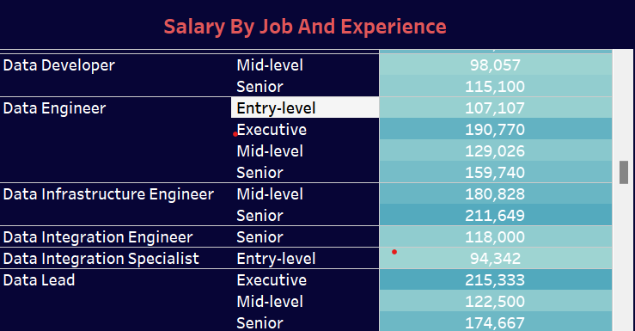

##### ****3.2 Geographic Salary Comparison****

A world map displays average salaries for data roles in different countries. This helps identify geographic trends and disparities in compensation.

**Key Findings**:

* **United States**, **Canada**, and **Australia** offer the highest average salaries, making them attractive locations for data professionals.
* **India**, **Brazil**, and other regions in **Asia** and **Latin America** tend to offer significantly lower salaries, despite the growing presence of data roles in these areas.
* The map also shows countries with emerging data job markets, where salary ranges may rise as demand increases.

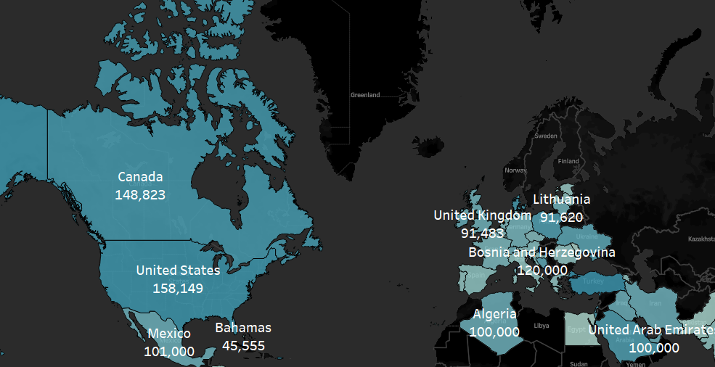

##### ****3.3 Salary Trends by Experience Level****

A line chart showcases how salaries change across experience levels, from entry-level to senior positions. This helps job seekers understand how experience affects compensation.

**Key Findings**:

* Salaries increase significantly as professionals move from **Mid-level** to **Senior** positions, often doubling or tripling in some cases.
* Entry-level positions offer lower starting salaries but see rapid growth after a few years of experience.
* The steepest salary increases occur between **Mid** and **Senior** levels, especially for roles like **Data Scientist** and **Data Architect**.

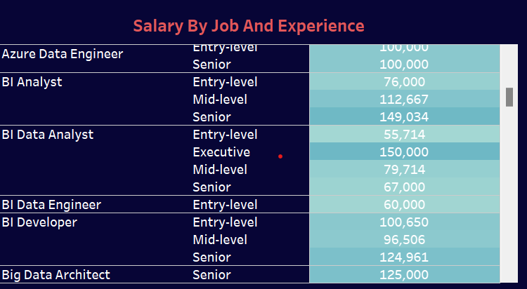

##### ****3.4 Employment Type and Work Setting Analysis****

A pie chart breaks down the employment types (e.g., Full-time vs. Part-time) and work settings (e.g., Remote, Hybrid, In-person), providing insight into how the job market is adapting to new working conditions.

**Key Findings**:

* **Full-time employment** is dominant, with very few part-time roles in the data science sector.
* Remote and hybrid working models have become highly prevalent, reflecting a shift towards flexibility in the workplace.
* **In-person** roles are now less common, with companies offering more remote or hybrid options, particularly in tech-driven roles like **Data Engineering** and **Data Science**.

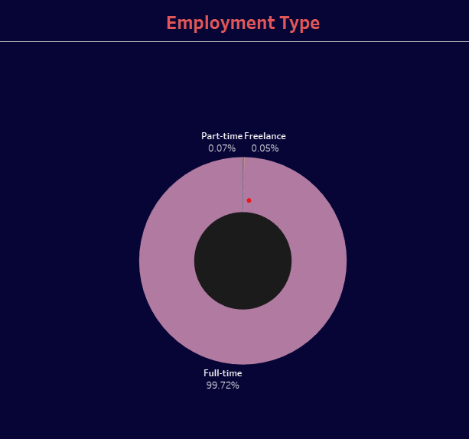

##### ****3.5 Company Size vs. Salary****

This bar chart compares salary averages based on company size (Small, Medium, Large). It helps in understanding whether larger companies offer better compensation than smaller ones.

**Key Findings**:

* **Large companies** (denoted as "L") offer the highest salaries, particularly for senior roles in **Data Architecture** and **Data Science**.
* **Medium-sized companies** ("M") provide competitive salaries, though typically lower than those of large organizations.
* **Small companies** ("S") tend to offer lower starting salaries, but some roles, particularly in **Data Engineering**, offer growth potential as these companies scale.

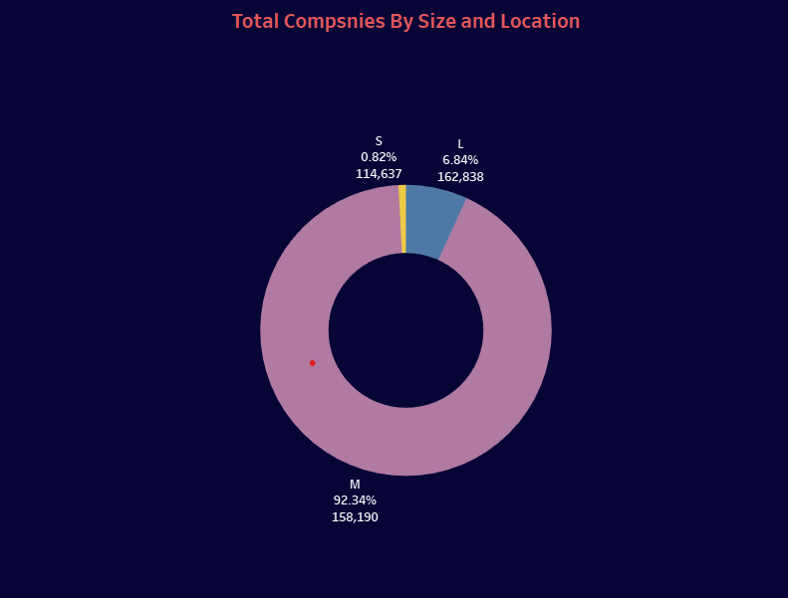

#### ****4. Conclusion****

This Tableau report sheds light on key trends in the data-related job market, particularly in terms of salaries, experience levels, and geographic distribution. Companies in **the United States** and **Germany** offer the highest compensation, while remote and hybrid work arrangements are becoming increasingly common. Senior roles command significantly higher salaries, particularly in fields like **Data Architecture** and **Data Engineering**.

This analysis provides valuable insights for job seekers looking to understand salary trends and for companies aiming to stay competitive in attracting top talent.